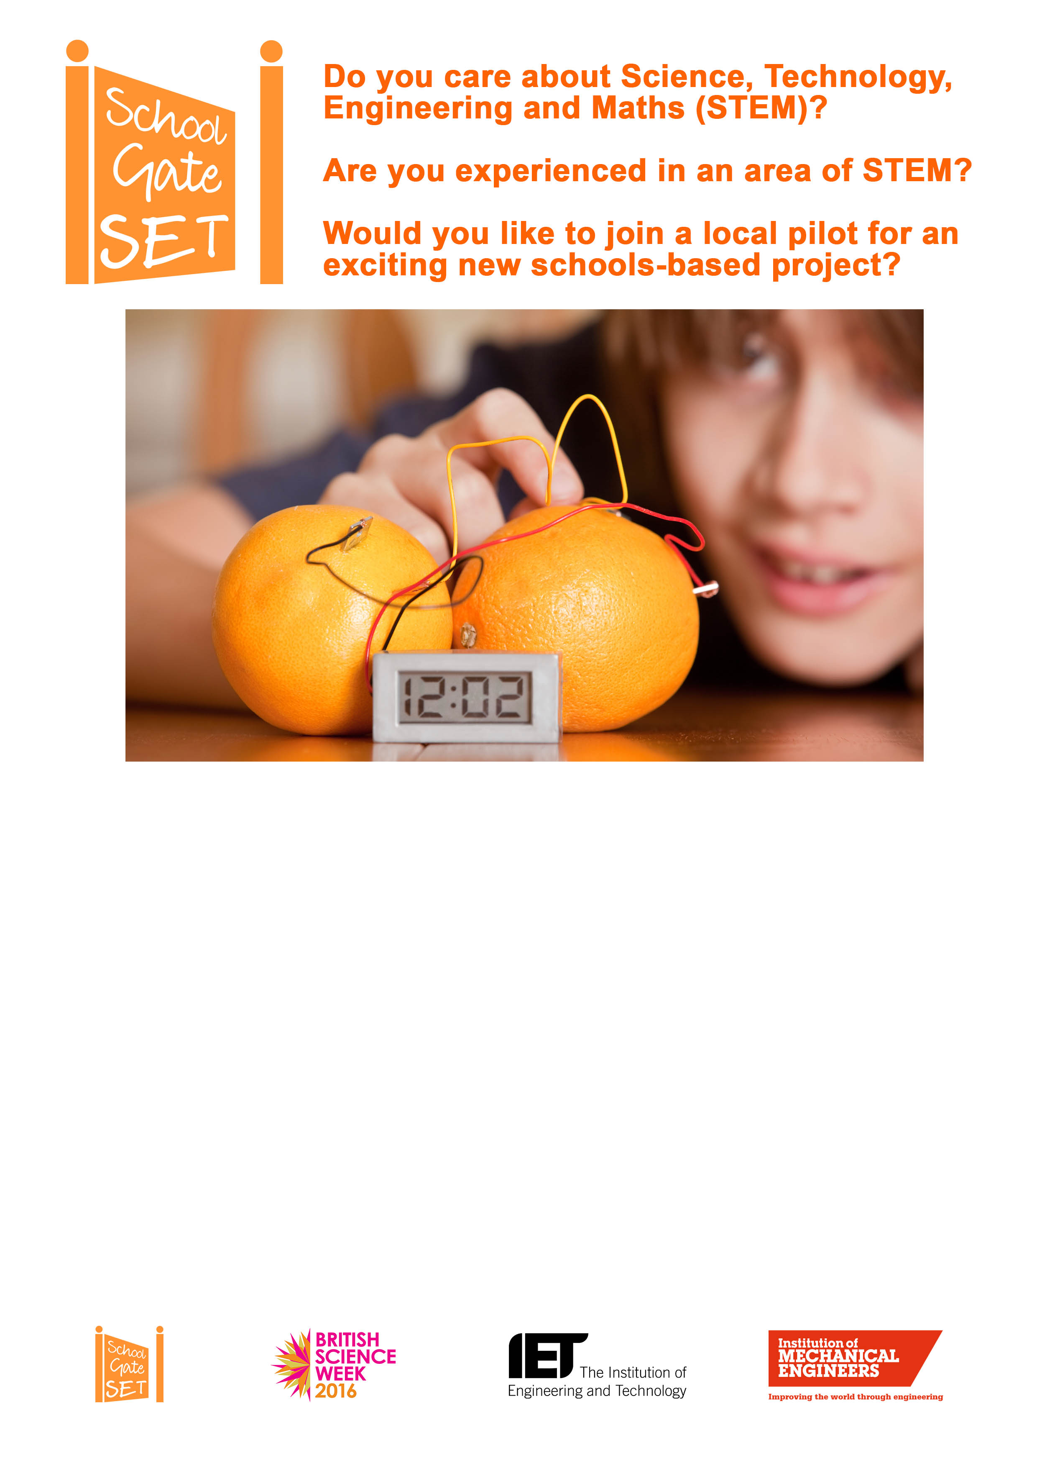
School Gate SET is working with Name of School to develop parent and carer volunteers who want to:

- Support STEM learning
- Work with children
- Devote at least ONE HOUR per week (9 am - 4.30 pm) between now and British Science Week (11- 20 March 2016)

Support will be given for all activities.
The staff contact is MR/S X

To show your interest in the first instance, please email Helen on schoolgateset@gmail.com and we will be in touch.

School gate SET is a project funded by Institute of Engineering and Technology and the Institute of Mechanical Engineering. Visit the website http://schoolgateset.blogspot.co.uk/

